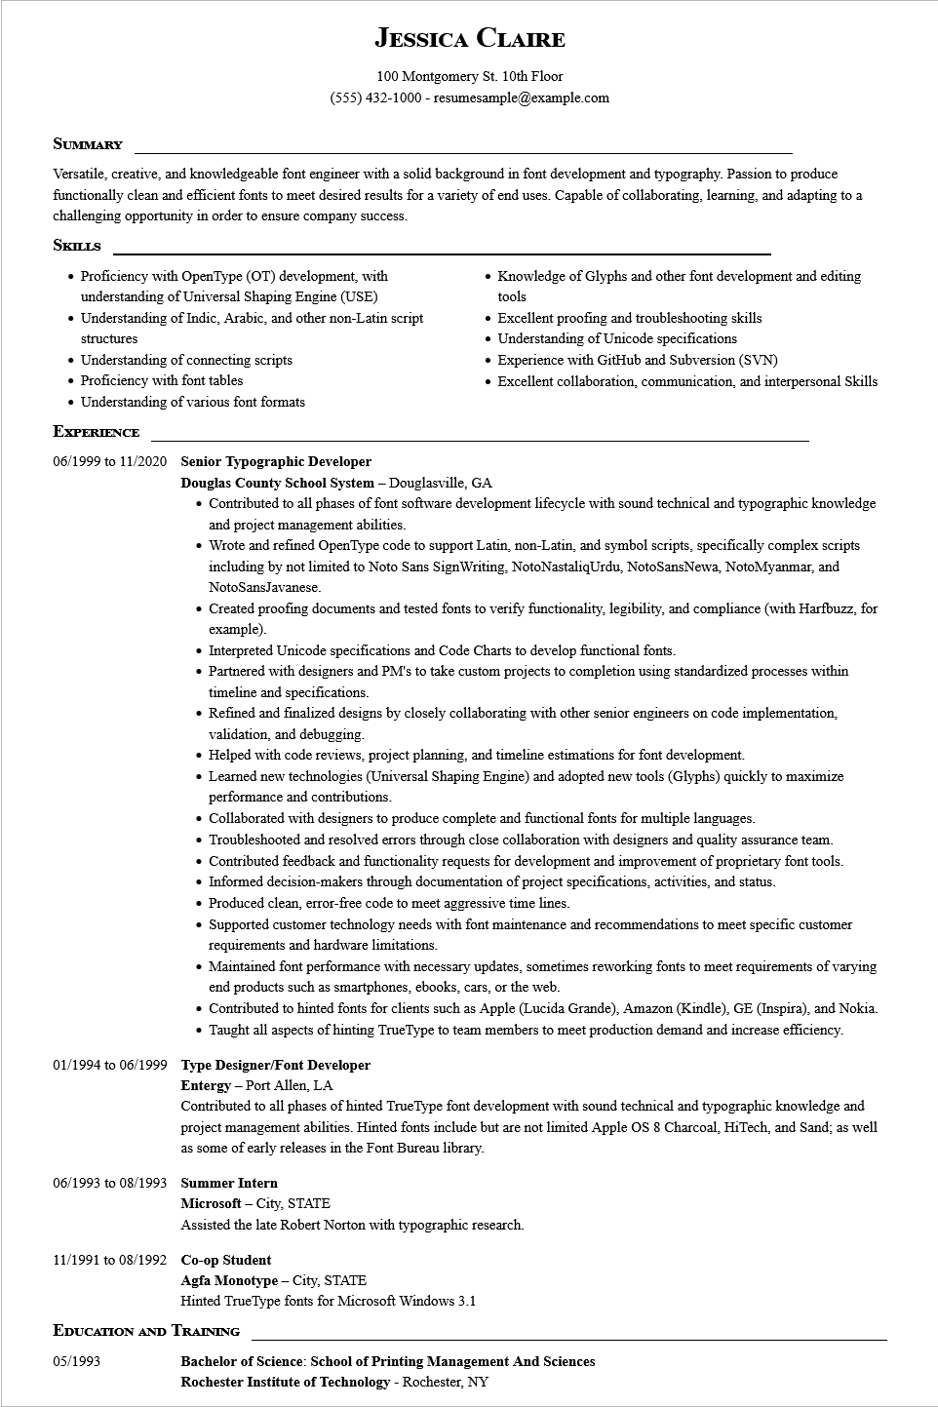
JESSICA CLAIRE
100 Montgomery St. 10th Floor (555) 432-1000-resumesample@example.com
SUMMARY
Versatile, creative, and knowledgeable font engineer with a solid background in font development and typography. Passion to produce functionally clean and efficient fonts to meet desired results for a variety of end uses. Capable of collaborating, learning, and adapting to a challenging opportunity in order to ensure company success.
SKILLS
• Proficiency with OpenType (OT) development, with understanding of Universal Shaping Engine (USE)
• Understanding of Indic, Arabic, and other non-Latin script structures
• Understanding of connecting scripts
• Proficiency with font tables
• Understanding of various font formats
Knowledge of Glyphs and other font development and editing tools
• Excellent proofing and troubleshooting skills
• Understanding of Unicode specifications
• Experience with GitHub and Subversion (SVN)
• Excellent collaboration, communication, and interpersonal Skills
EXPERIENCE
06/1999 to 11/2020 Senior Typographic Developer
Douglas County School System - Douglasville, GA
Contributed to all phases of font software development lifecycle with sound technical and typographic knowledge and project management abilities.
• Wrote and refined OpenType code to support Latin, non-Latin, and symbol scripts, specifically complex scripts including by not limited to Noto Sans SignWriting, NotoNastaliqUrdu, NotoSansNewa, NotoMyanmar, and NotoSansJavanese.
Created proofing documents and tested fonts to verify functionality, legibility, and compliance (with Harfbuzz, for example).
• Interpreted Unicode specifications and Code Charts to develop functional fonts.
• Partnered with designers and PM's to take custom projects to completion using standardized processes within timeline and specifications.
• Refined and finalized designs by closely collaborating with other senior engineers on code implementation, validation, and debugging.
• Helped with code reviews, project planning, and timeline estimations for font development.
• Learned new technologies (Universal Shaping Engine) and adopted new tools (Glyphs) quickly to maximize performance and contributions.
• Collaborated with designers to produce complete and functional fonts for multiple languages.
• Troubleshooted and resolved errors through close collaboration with designers and quality assurance team.
• Contributed feedback and functionality requests for development and improvement of proprietary font tools.
• Informed decision-makers through documentation of project specifications, activities, and status.
• Produced clean, error-free code to meet aggressive time lines.
• Supported customer technology needs with font maintenance and recommendations to meet specific customer requirements and hardware limitations.
• Maintained font performance with necessary updates, sometimes reworking fonts to meet requirements of varying end products such as smartphones, ebooks, cars, or the web.
Contributed to hinted fonts for clients such as Apple (Lucida Grande), Amazon (Kindle), GE (Inspira), and Nokia. Taught all aspects of hinting TrueType to team members to meet production demand and increase efficiency.
01/1994 to 06/1999 Type Designer/Font Developer
Entergy - Port Allen, LA
Contributed to all phases of hinted TrueType font development with sound technical and typographic knowledge and project management abilities. Hinted fonts include but are not limited Apple OS 8 Charcoal, HiTech, and Sand; as well as some of early releases in the Font Bureau library.
06/1993 to 08/1993 Summer Intern
Microsoft - City, STATE
Assisted the late Robert Norton with typographic research.
11/1991 to 08/1992 Co-op Student
Agfa Monotype-City, STATE
Hinted TrueType fonts for Microsoft Windows 3.1
EDUCATION AND TRAINING
05/1993
Bachelor of Science: School of Printing Management And Sciences Rochester Institute of Technology - Rochester, NY

